Slovenia, August 1, 2024.

**Beekeepers' Call to Consumers:**

**LET'S PUT AN END TO   
FAKE HONEY TOGETHER!**

Don't we Europeans really deserve to enjoy real food?

Can't we really come together, both food producers and consumers, and put an end to fake food on the market, which is indeed low-priced but at the same time often even harmful to health! Unfortunately for beekeepers and consumers, HONEY is one of the most commonly adulterated foods.

The European Beekeeping Association has almost 300,000 beekeepers from 19 European countries, and the main goal of this association is to protect the consumer from consuming fake bee products and, as a result, preserve bees and beekeeping!

Today, the bee is endangered in Europe, because unfortunately it cannot survive without the help of the beekeeper! Due to fake bee products on the market (according to the official data of the EU Commission, almost 50% of them and most of them are imported from outside the Europe) and thus unfair competition, the entire European beekeeping is at risk, the collapse of beekeepers means the collapse of bees and consequently the end of the pollination service of bees, which  is a prerequisite for food production in Europe, as every third spoonful of food depends on bee pollination!

Food security in Europe can only be ensured by European farmers, honey (and mostly "honey", which is not real honey at all) can be imported, but not the bee pollination service!

The presence of bees and other pollinators is therefore necessary for the production of European food.

In order to preserve bees and beekeeping, we must immediately put an absolute STOP to all fake bee products and at the same time support beekeeping and agriculture by buying local bee products, which are proven to strengthen our health the best!

The new leadership of the European Union has been elected, the European Beekeeping Association publicly calls on all European Members of Parliament, European Commissioners and other decision-makers in the EU and in individual countries to protect the European beekeeper, to protect the European farmer, because without bees there will be no agriculture and to protect the European consumer against adulterated food.

The European Beekeeping Association will immediately contact the decision-makers in the European area, and we believe that together we will find a solution.

I am convinced that we all want and deserve to enjoy real food!

﻿Boštjan Noč

President of the European Beekeeping Association

eba@ebaeurope.eu

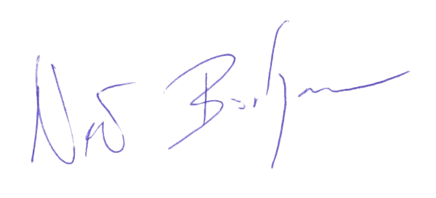

GENERAL SPONSOR OF THE EBA

